EXP NO : 4.1 Implement Classification Model Using KNN and Compute Evaluation Metrics

AIM : To implement the K-Nearest Neighbors (KNN) classification algorithm using Python to predict students' results based on their study hours, attendance, and assignments, and evaluate the model using accuracy, confusion matrix, and classification report.

ALGORITHM :
- Start the program.
- Import Pandas and the required functions from Scikit-learn.
- Load the dataset from the file data.csv.
- Select Hours_Studied, Attendance, and Assignments as input features.
- Select Result as the target variable.
- Split the dataset into training and testing sets in an 80:20 ratio using train_test_split().
- Create a KNN classification model with n_neighbors=3.
- Train the model using the training data with model.fit().
- Predict the results for the testing data using model.predict().
- Calculate and display the model's accuracy using accuracy_score().
- Display the confusion matrix using confusion_matrix().
- Display the classification report using classification_report(), including precision, recall, and F1-score.
- Stop the program.
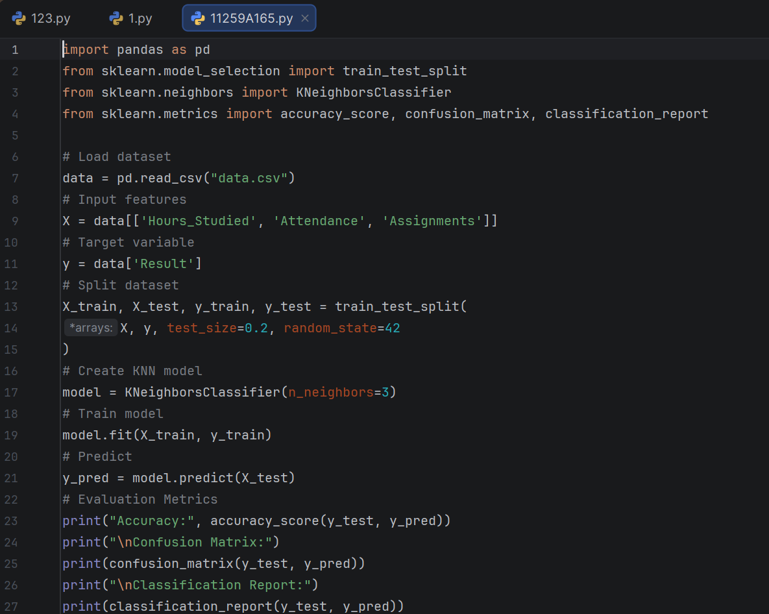
PROGRAM :

OUTPUT :
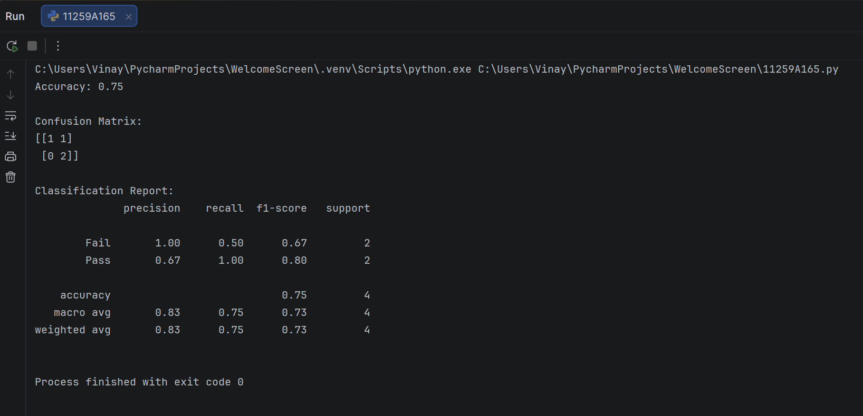

RESULT : Thus, the Simple Linear Regression model was implemented successfully to predict students' marks based on their study hours. The Mean Squared Error, R² Score, and predicted marks were displayed, and a graph showing the actual data points and the regression line was plotted.

EXP NO : 4.2 Implement Classification Model Using SVM and Compute Evaluation Metrics
AIM : To implement a Support Vector Machine (SVM) classification algorithm using Python to predict students' results based on their study hours, attendance, and assignments, and evaluate the model using accuracy, confusion matrix, and classification report.

ALGORITHM :
- Start the program.
- Import the Pandas library and the required functions from Scikit-learn.
- Load the dataset from the file data.csv.
- Select Hours_Studied, Attendance, and Assignments as input features.
- Select Result as the target variable.
- Split the dataset into training and testing sets in an 80:20 ratio using train_test_split().
- Create an SVM classification model using SVC(kernel='linear').
- Train the model using the training data with model.fit().
- Predict the students' results for the testing data using model.predict().
- Calculate and display the model's accuracy using accuracy_score().
- Display the confusion matrix using confusion_matrix().
- Display the classification report using classification_report(), which includes precision, recall, F1-score, and support.
- Stop the program.

PROGRAM :

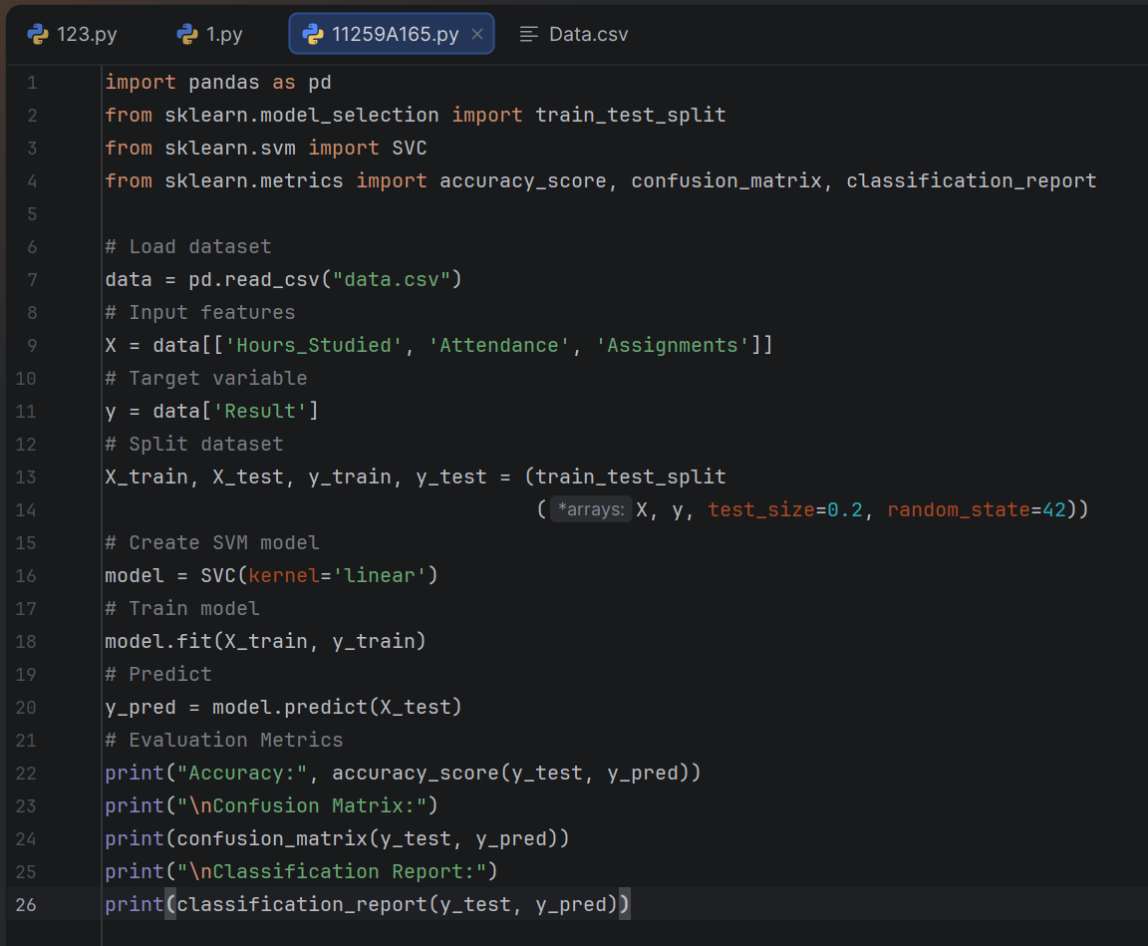

OUTPUT :
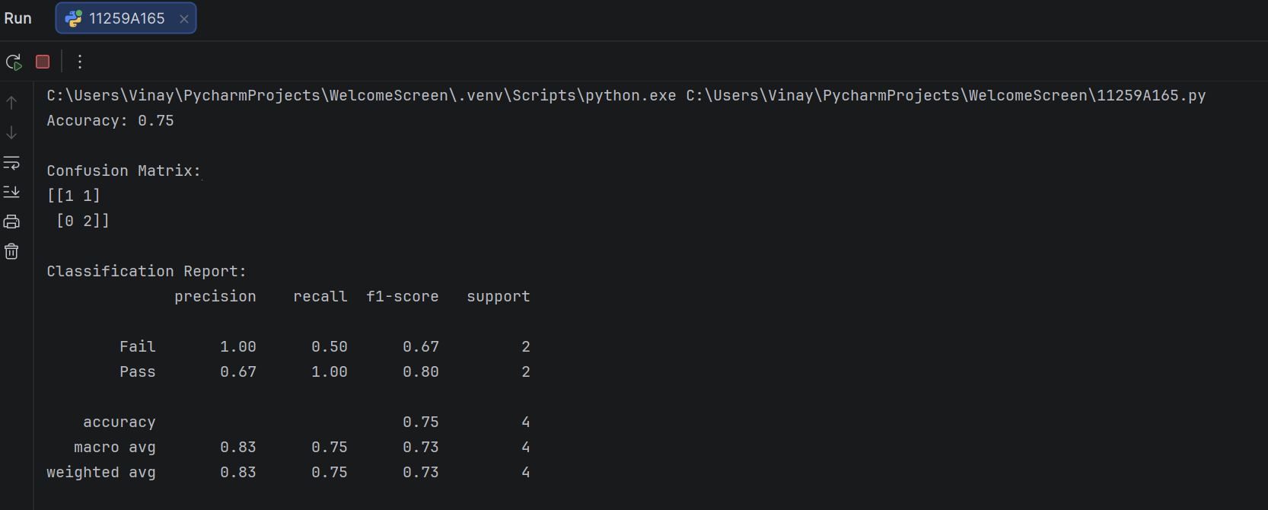

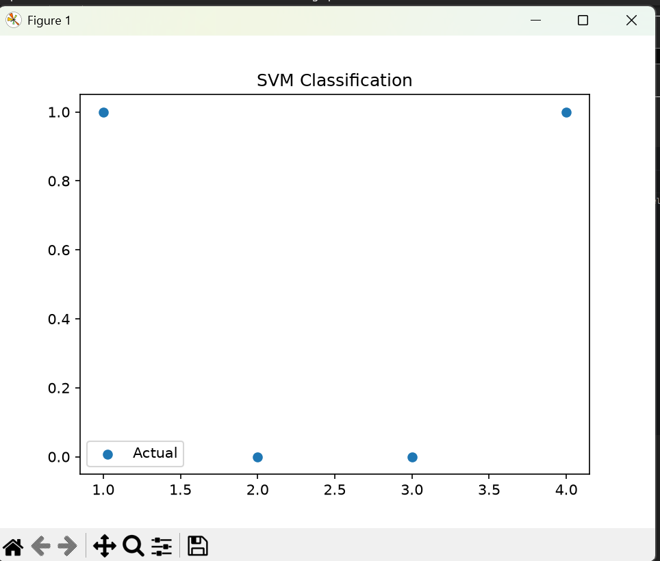

RESULT : Thus, the Support Vector Machine (SVM) classification algorithm was implemented successfully to predict students' results based on their study hours, attendance, and assignments. The model's performance was evaluated using accuracy, confusion matrix, precision, recall, and F1-score.

